SQL Delete

🌟 Definition
# Source: AI Source: Provided by: [Data Path: Persons Table -> ID Column: 1, Name_En Column: Motasem Essam] -> From: [ChatGPT] on [6/11/2026]
SQL DELETE is a statement used to remove one or more rows (records) from a table.
Unlike DROP TABLE, which removes the entire table, DELETE removes only the selected data while keeping the table structure.

🎯 Purpose
# Source: AI Source: Provided by: [Data Path: Persons Table -> ID Column: 1, Name_En Column: Motasem Essam] -> From: [ChatGPT] on [6/11/2026]
DELETE is used to:
- Remove old records
- Delete inactive users
- Remove cancelled orders
- Delete duplicate data
- Clean up unnecessary records

🧠 Simple Example
# Source: AI Source: Provided by: [Data Path: Persons Table -> ID Column: 1, Name_En Column: Motasem Essam] -> From: [ChatGPT] on [6/11/2026]
Customers Table
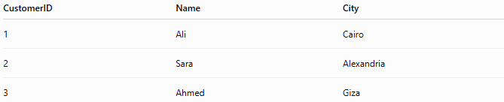
CustomerID | Name | City
1 | Ali | Cairo
2 | Sara | Alexandria
3 | Ahmed | Giza

SQL Statement
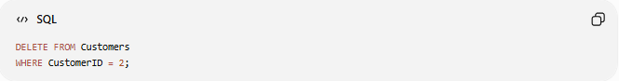
DELETE FROM Customers
WHERE CustomerID = 2;

Result
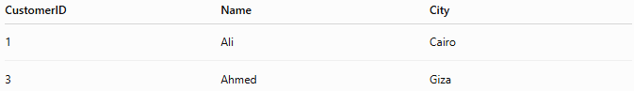
CustomerID | Name | City
1 | Ali | Cairo
3 | Ahmed | Giza
The row for Sara has been removed.

📝 Syntax
# Source: AI Source: Provided by: [Data Path: Persons Table -> ID Column: 1, Name_En Column: Motasem Essam] -> From: [ChatGPT] on [6/11/2026]
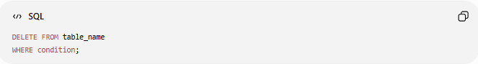
DELETE FROM table_name
WHERE condition;

Syntax Breakdown
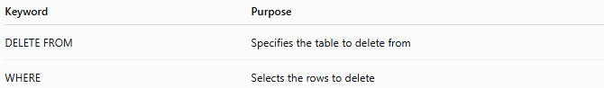
Keyword | Purpose
DELETE FROM | Specifies the table to delete from
WHERE | Selects the rows to delete

📚 Example 1: Delete One Row
# Source: AI Source: Provided by: [Data Path: Persons Table -> ID Column: 1, Name_En Column: Motasem Essam] -> From: [ChatGPT] on [6/11/2026]
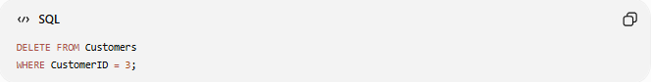
DELETE FROM Customers
WHERE CustomerID = 3;

Before
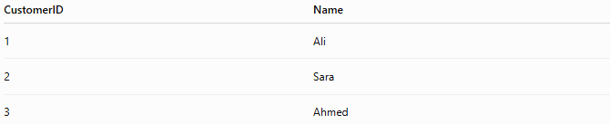
CustomerID | Name
1 | Ali
2 | Sara
3 | Ahmed

After
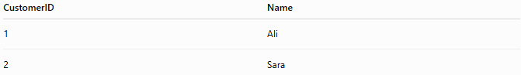
CustomerID | Name
1 | Ali
2 | Sara

📚 Example 2: Delete Multiple Rows
# Source: AI Source: Provided by: [Data Path: Persons Table -> ID Column: 1, Name_En Column: Motasem Essam] -> From: [ChatGPT] on [6/11/2026]
Delete all customers from Cairo.
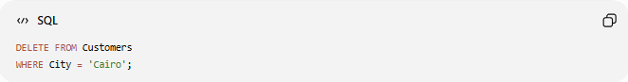
DELETE FROM Customers
WHERE City = 'Cairo';

Before
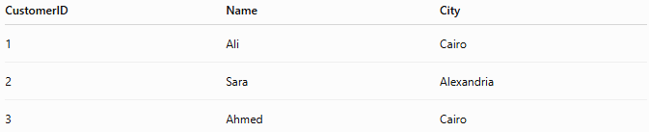
CustomerID | Name | City
1 | Ali | Cairo
2 | Sara | Alexandria
3 | Ahmed | Cairo

After
CustomerID | Name | City
2 | Sara | Alexandria

📚 Example 3: Delete All Rows
# Source: AI Source: Provided by: [Data Path: Persons Table -> ID Column: 1, Name_En Column: Motasem Essam] -> From: [ChatGPT] on [6/11/2026]

DELETE FROM Customers;

Result
CustomerID | Name | City
The table still exists, but all rows are removed.

⚠️ Importance of WHERE
# Source: AI Source: Provided by: [Data Path: Persons Table -> ID Column: 1, Name_En Column: Motasem Essam] -> From: [ChatGPT] on [6/11/2026]
Safe Delete
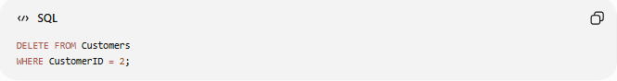
DELETE FROM Customers
WHERE CustomerID = 2;
Deletes only one row.

Dangerous Delete
DELETE FROM Customers;
Deletes every row in the table.

📊 Before and After Example
# Source: AI Source: Provided by: [Data Path: Persons Table -> ID Column: 1, Name_En Column: Motasem Essam] -> From: [ChatGPT] on [6/11/2026]
Before
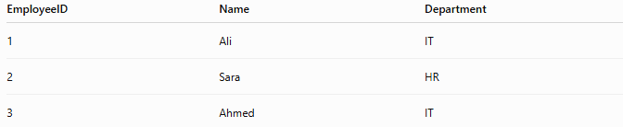
EmployeeID | Name | Department
1 | Ali | IT
2 | Sara | HR
3 | Ahmed | IT

Query
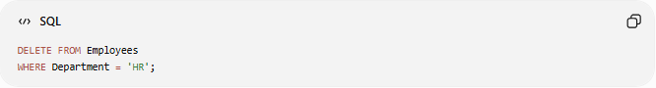
DELETE FROM Employees
WHERE Department = 'HR';

After
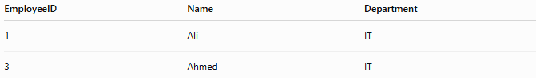
EmployeeID | Name | Department
1 | Ali | IT
3 | Ahmed | IT

📚 Example 4: Delete Using Multiple Conditions
# Source: AI Source: Provided by: [Data Path: Persons Table -> ID Column: 1, Name_En Column: Motasem Essam] -> From: [ChatGPT] on [6/11/2026]
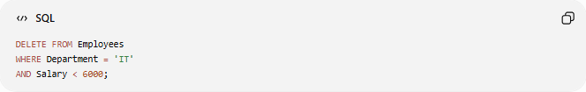
DELETE FROM Employees
WHERE Department = 'IT'
AND Salary < 6000;
Deletes only employees who meet both conditions.

📊 DELETE vs TRUNCATE vs DROP
# Source: AI Source: Provided by: [Data Path: Persons Table -> ID Column: 1, Name_En Column: Motasem Essam] -> From: [ChatGPT] on [6/11/2026]
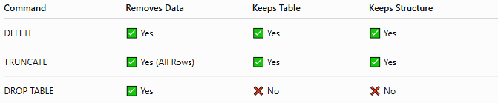
Command | Removes Data | Keeps Table | Keeps Structure
DELETE | ✅ Yes | ✅ Yes | ✅ Yes
TRUNCATE | ✅ Yes (All Rows) | ✅ Yes | ✅ Yes
DROP TABLE | ✅ Yes | ❌ No | ❌ No

DELETE
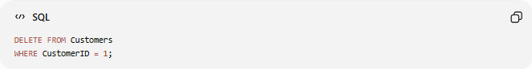
DELETE FROM Customers
WHERE CustomerID = 1;
Deletes selected rows.

TRUNCATE
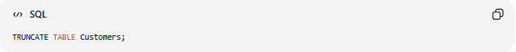
TRUNCATE TABLE Customers;
Deletes all rows quickly.

DROP

DROP TABLE Customers;
Deletes the table completely.

🛠️ Complete Example
# Source: AI Source: Provided by: [Data Path: Persons Table -> ID Column: 1, Name_En Column: Motasem Essam] -> From: [ChatGPT] on [6/11/2026]
Create Table
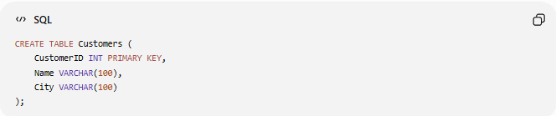
CREATE TABLE Customers (
CustomerID INT PRIMARY KEY,
Name VARCHAR(100),
City VARCHAR(100)
);

Insert Data
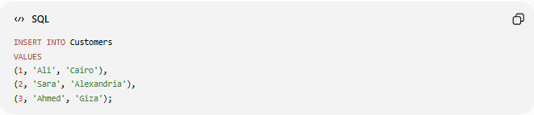
INSERT INTO Customers
VALUES
(1, 'Ali', 'Cairo'),
(2, 'Sara', 'Alexandria'),
(3, 'Ahmed', 'Giza');

Delete One Customer
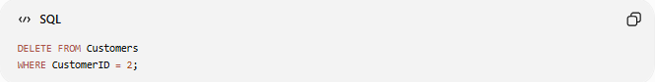
DELETE FROM Customers
WHERE CustomerID = 2;

Check Result
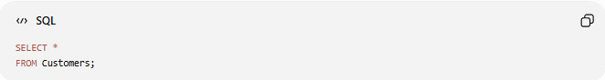
SELECT *
FROM Customers;

Result
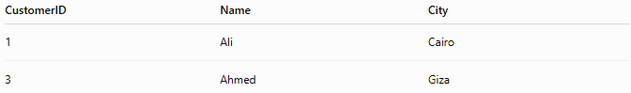
CustomerID | Name | City
1 | Ali | Cairo
3 | Ahmed | Giza

⚠️ Common Errors
# Source: AI Source: Provided by: [Data Path: Persons Table -> ID Column: 1, Name_En Column: Motasem Essam] -> From: [ChatGPT] on [6/11/2026]
Forgetting WHERE

DELETE FROM Customers;
Removes all records.

Wrong Column Name
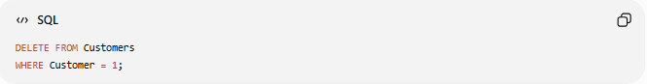
DELETE FROM Customers
WHERE Customer = 1;
Error if Customer does not exist.

Deleting Referenced Data
If a row is referenced by a FOREIGN KEY, the delete may fail unless cascading rules are configured.
Example:

DELETE FROM Customers
WHERE CustomerID = 1;
If related orders exist, the database may prevent deletion.

📊 Side-by-Side Comparison
# Source: AI Source: Provided by: [Data Path: Persons Table -> ID Column: 1, Name_En Column: Motasem Essam] -> From: [ChatGPT] on [6/11/2026]
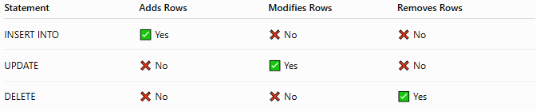
Statement | Adds Rows | Modifies Rows | Removes Rows
INSERT INTO | ✅ Yes | ❌ No | ❌ No
UPDATE | ❌ No | ✅ Yes | ❌ No
DELETE | ❌ No | ❌ No | ✅ Yes

🧪 Complete Test Example

1️⃣ Create Table
# Source: AI Source: Provided by: [Data Path: Persons Table -> ID Column: 1, Name_En Column: Motasem Essam] -> From: [ChatGPT] on [6/11/2026]
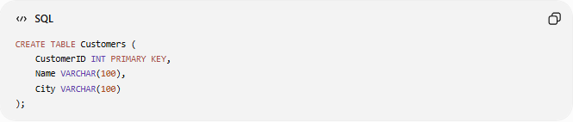
CREATE TABLE Customers (
CustomerID INT PRIMARY KEY,
Name VARCHAR(100),
City VARCHAR(100)
);

2️⃣ Insert Sample Data
# Source: AI Source: Provided by: [Data Path: Persons Table -> ID Column: 1, Name_En Column: Motasem Essam] -> From: [ChatGPT] on [6/11/2026]
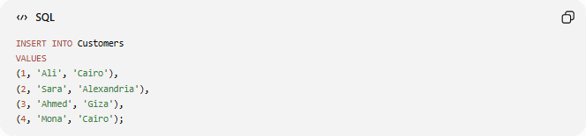
INSERT INTO Customers
VALUES
(1, 'Ali', 'Cairo'),
(2, 'Sara', 'Alexandria'),
(3, 'Ahmed', 'Giza'),
(4, 'Mona', 'Cairo');

3️⃣ View Data
# Source: AI Source: Provided by: [Data Path: Persons Table -> ID Column: 1, Name_En Column: Motasem Essam] -> From: [ChatGPT] on [6/11/2026]

SELECT * FROM Customers;
Result
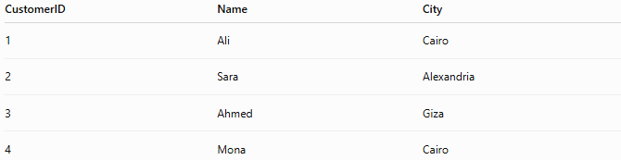
CustomerID | Name | City
1 | Ali | Cairo
2 | Sara | Alexandria
3 | Ahmed | Giza
4 | Mona | Cairo

4️⃣ Delete One Record
# Source: AI Source: Provided by: [Data Path: Persons Table -> ID Column: 1, Name_En Column: Motasem Essam] -> From: [ChatGPT] on [6/11/2026]
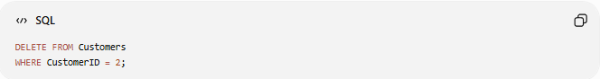
DELETE FROM Customers
WHERE CustomerID = 2;

5️⃣ View Result
# Source: AI Source: Provided by: [Data Path: Persons Table -> ID Column: 1, Name_En Column: Motasem Essam] -> From: [ChatGPT] on [6/11/2026]
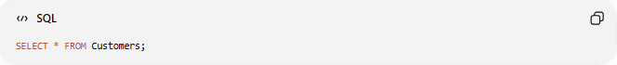
SELECT * FROM Customers;
Result
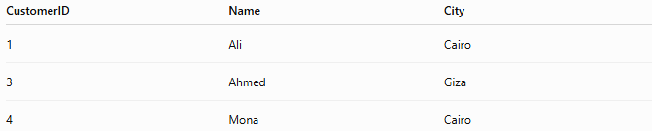
CustomerID | Name | City
1 | Ali | Cairo
3 | Ahmed | Giza
4 | Mona | Cairo

6️⃣ Delete All Customers from Cairo
# Source: AI Source: Provided by: [Data Path: Persons Table -> ID Column: 1, Name_En Column: Motasem Essam] -> From: [ChatGPT] on [6/11/2026]
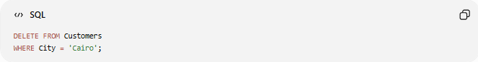
DELETE FROM Customers
WHERE City = 'Cairo';

7️⃣ Final Result
# Source: AI Source: Provided by: [Data Path: Persons Table -> ID Column: 1, Name_En Column: Motasem Essam] -> From: [ChatGPT] on [6/11/2026]

SELECT * FROM Customers;
CustomerID | Name | City
3 | Ahmed | Giza

Real Example

prepared commands

1️⃣ Create Table
# Source: ScreenShot Source: Provided by: [Persons Table -> ID Column: 1, Name_En Column: Motasem Essam] -> Tool: [Automation Table -> ID Column: 16, Name_En Column: Screen Capture] -> From [Operating System: Wampserver64 -> phpmyadmin] on [6/11/2026]
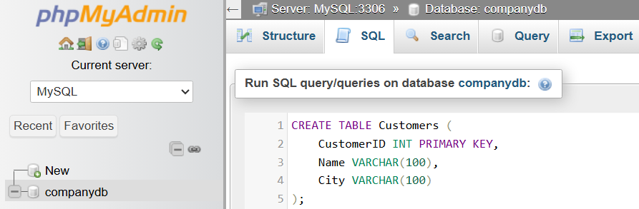
CREATE TABLE Customers (
CustomerID INT PRIMARY KEY,
Name VARCHAR(100),
City VARCHAR(100)
);
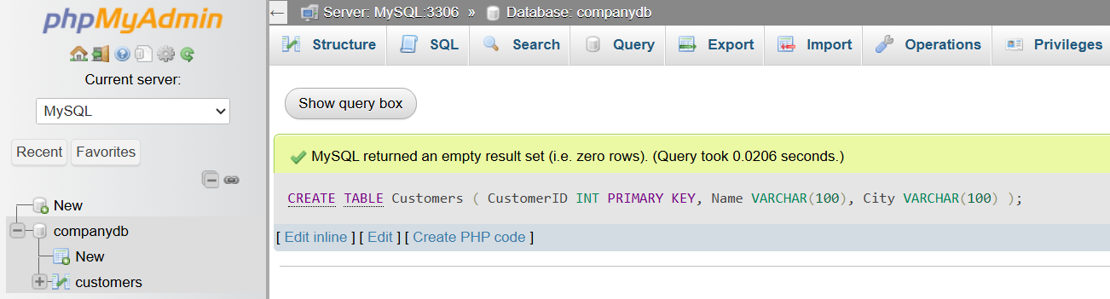

2️⃣ Insert Sample Data
# Source: ScreenShot Source: Provided by: [Persons Table -> ID Column: 1, Name_En Column: Motasem Essam] -> Tool: [Automation Table -> ID Column: 16, Name_En Column: Screen Capture] -> From [Operating System: Wampserver64 -> phpmyadmin] on [6/11/2026]
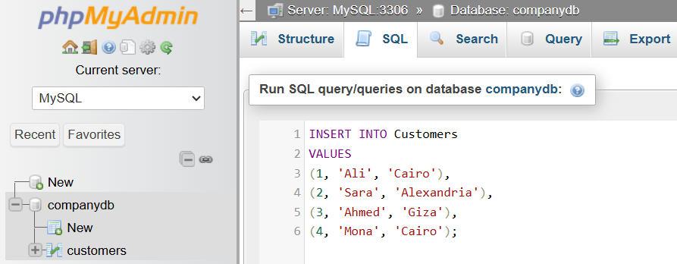
INSERT INTO Customers
VALUES
(1, 'Ali', 'Cairo'),
(2, 'Sara', 'Alexandria'),
(3, 'Ahmed', 'Giza'),
(4, 'Mona', 'Cairo');
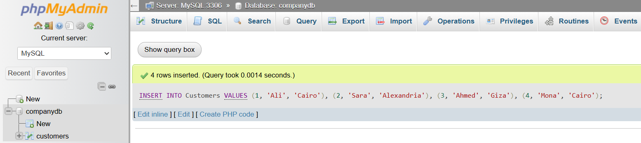

3️⃣ View Data
# Source: ScreenShot Source: Provided by: [Persons Table -> ID Column: 1, Name_En Column: Motasem Essam] -> Tool: [Automation Table -> ID Column: 16, Name_En Column: Screen Capture] -> From [Operating System: Wampserver64 -> phpmyadmin] on [6/11/2026]
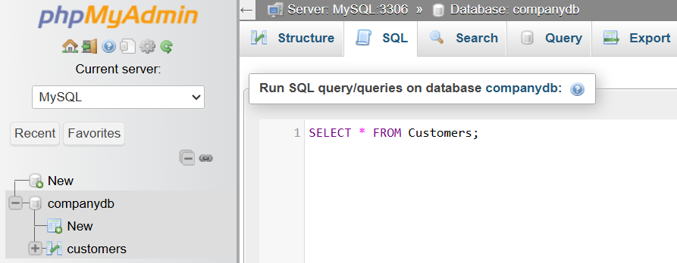
SELECT * FROM Customers;
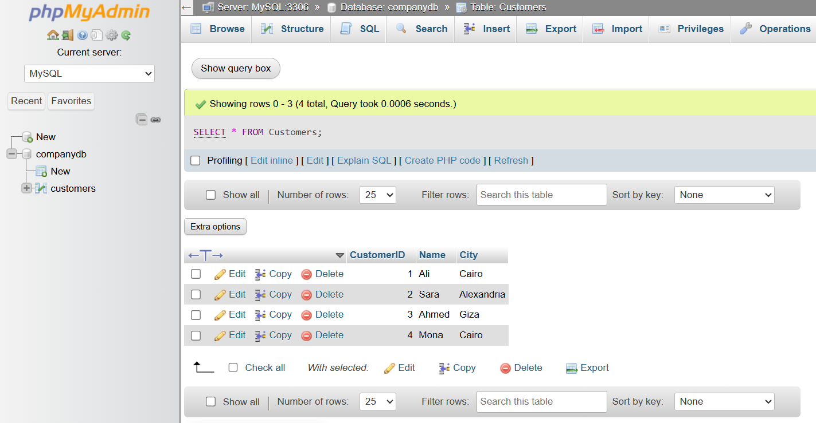

basic command

4️⃣ Delete One Record
# Source: ScreenShot Source: Provided by: [Persons Table -> ID Column: 1, Name_En Column: Motasem Essam] -> Tool: [Automation Table -> ID Column: 16, Name_En Column: Screen Capture] -> From [Operating System: Wampserver64 -> phpmyadmin] on [6/11/2026]
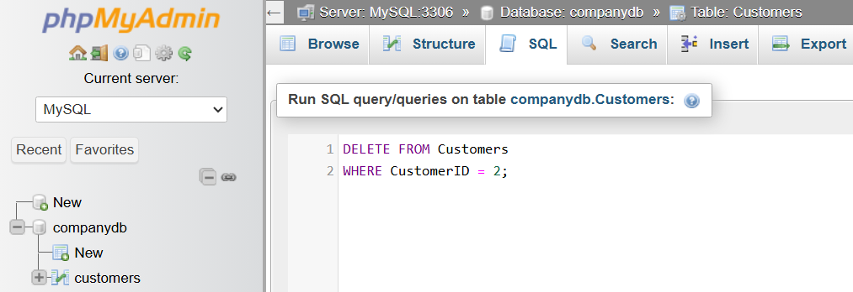
DELETE FROM Customers
WHERE CustomerID = 2;
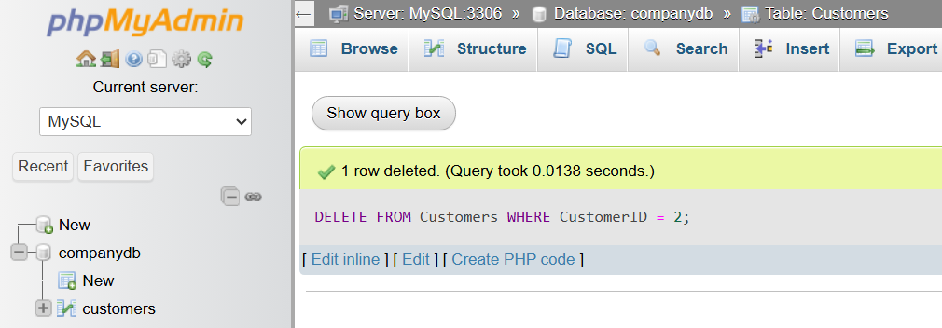

5️⃣ View Result
# Source: ScreenShot Source: Provided by: [Persons Table -> ID Column: 1, Name_En Column: Motasem Essam] -> Tool: [Automation Table -> ID Column: 16, Name_En Column: Screen Capture] -> From [Operating System: Wampserver64 -> phpmyadmin] on [6/11/2026]
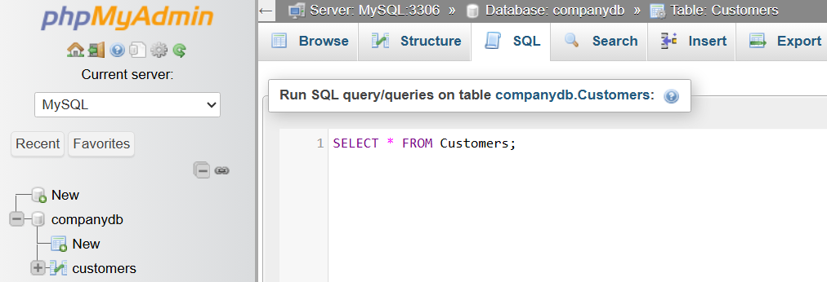
SELECT * FROM Customers;
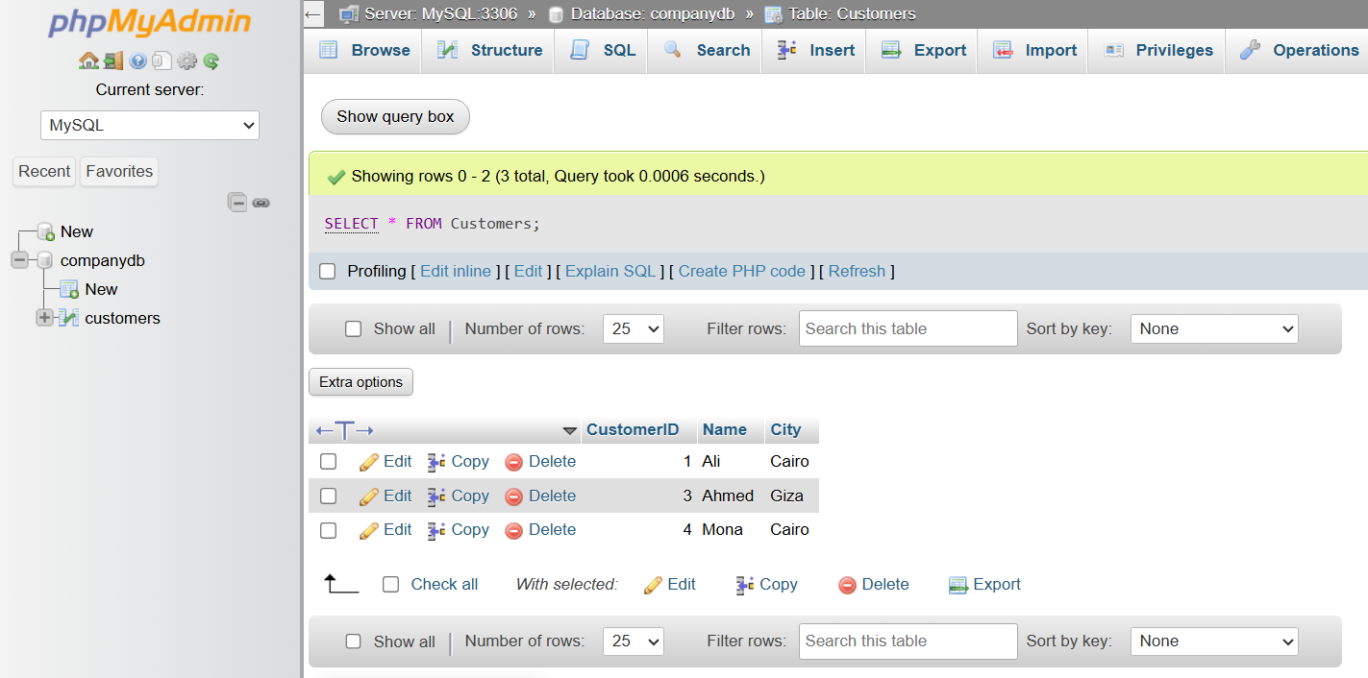

6️⃣ Delete All Customers from Cairo
# Source: ScreenShot Source: Provided by: [Persons Table -> ID Column: 1, Name_En Column: Motasem Essam] -> Tool: [Automation Table -> ID Column: 16, Name_En Column: Screen Capture] -> From [Operating System: Wampserver64 -> phpmyadmin] on [6/11/2026]
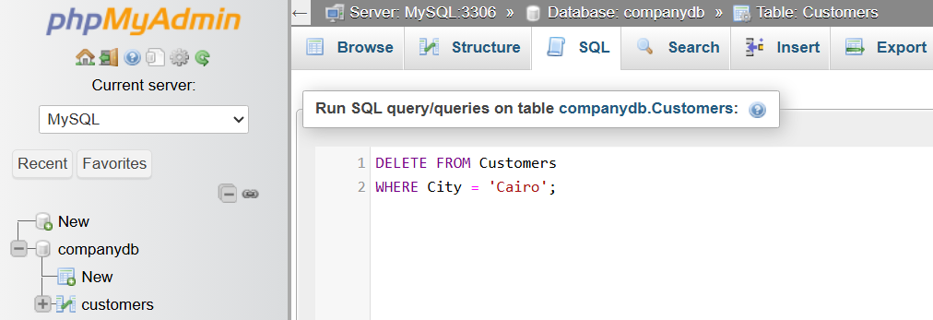
DELETE FROM Customers
WHERE City = 'Cairo';
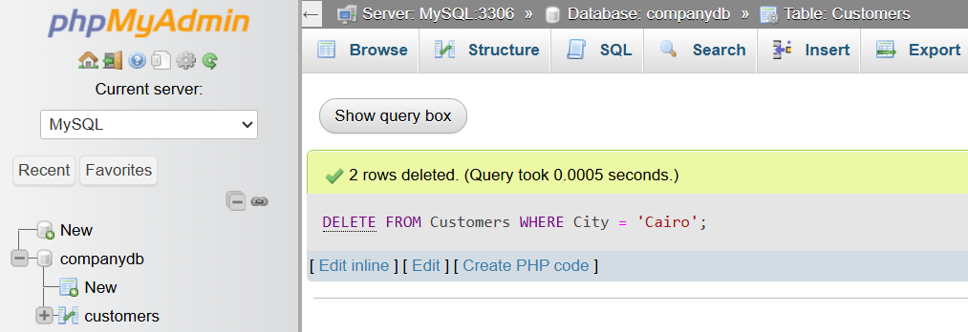

7️⃣ Final Result
# Source: ScreenShot Source: Provided by: [Persons Table -> ID Column: 1, Name_En Column: Motasem Essam] -> Tool: [Automation Table -> ID Column: 16, Name_En Column: Screen Capture] -> From [Operating System: Wampserver64 -> phpmyadmin] on [6/11/2026]
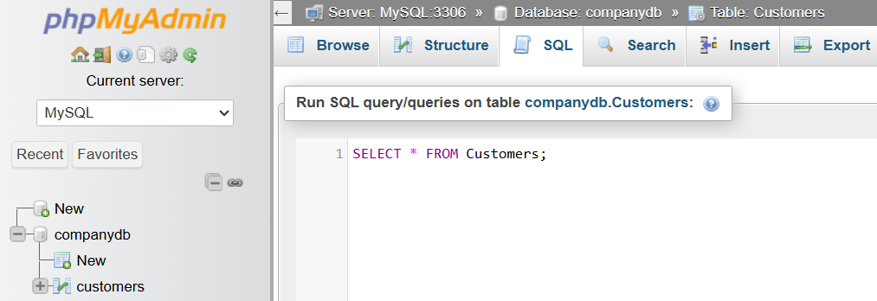
SELECT * FROM Customers;
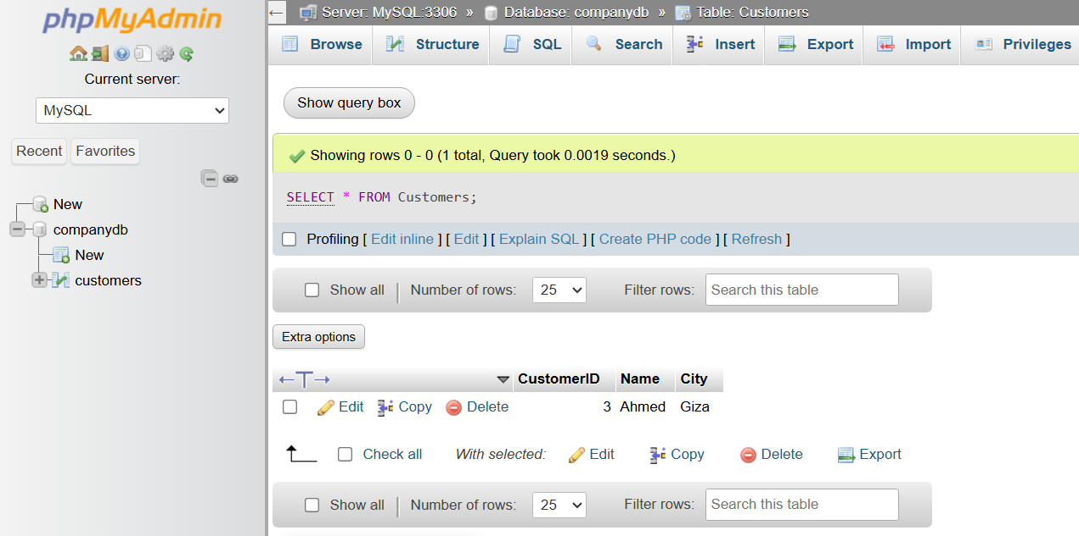

🔢 DELETE Workflow
# Source: AI Source: Provided by: [Data Path: Persons Table -> ID Column: 1, Name_En Column: Motasem Essam] -> From: [ChatGPT] on [6/11/2026]
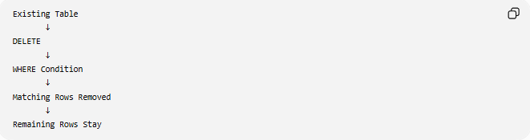
Existing Table
↓
DELETE
↓
WHERE Condition
↓
Matching Rows Removed
↓
Remaining Rows Stay

🧠 Simple Analogy
# Source: AI Source: Provided by: [Data Path: Persons Table -> ID Column: 1, Name_En Column: Motasem Essam] -> From: [ChatGPT] on [6/11/2026]
Think of a spreadsheet.
- INSERT INTO adds a new row.
- UPDATE edits an existing row.
- DELETE removes a row while leaving the spreadsheet intact.
- DROP TABLE throws away the entire spreadsheet.
Deleting a customer record is like erasing one row from the spreadsheet—not deleting the whole file.

🧭 Summary
# Source: AI Source: Provided by: [Data Path: Persons Table -> ID Column: 1, Name_En Column: Motasem Essam] -> From: [ChatGPT] on [6/11/2026]
SQL DELETE is used to remove one or more rows from a database table. It uses the WHERE clause to specify which records should be deleted. If the WHERE clause is omitted, all rows in the table are removed while the table structure remains. DELETE is a core DML (Data Manipulation Language) command used to remove unwanted or obsolete data safely.

